HIVE AND IMPALA BENCHMARK RESULTS

BY
KARUNAKAR NAIDU

Table of Contents

- CLUSTER INFORMATION 2
- DATA INFORMATION 2
- DEFAULT EXECUTION TIME IN HIVE 2
3.1 HIVE EXECUTION TIME WITH TWEAKED SETTINGS 2
3.2 APPLYING ALL ABOVE MENTIONED TWEAKED SETTINGS 9
4. IMPALA EXECUTION ON NATIVE HIVE TABLES 9
4.1 IMPALA EXECUTION ON NATIVE IMPALA TABLES 10
4.2 SAMPLE RESULT POST IMPALA EXECUTION 10
4.3 IMPALA EXECUTION TIME WITH TWEAKED SETTINGS 10
5 SUMMARY 13
5.1 HIVE PERFORMANCE RESULTS 13
5.2 IMPALA PERFORMANCE RESULTS 13

1. CLUSTER INFORMATION
DISTRIBUTION USED: Cloudera-quickstart-vm-4.2.1.p-vmware.
RAM ALLOCATED : 1.5GB
PROCESSORS : 1
HARD DISK : 17GB
HADOOP VERSION : 1
HIVE : 0.10.0
IMPALA : 1.0

2. DATA INFORMATION
A) CSV data of 60 files, each file consisting of 2040 rows and total size of files is 10MB.
B) CSV file containing weather locations with 60 rows of size 8KB.

3. DEFAULT EXECUTION TIME IN HIVE
The default execution time to get the result is 207.909 seconds.
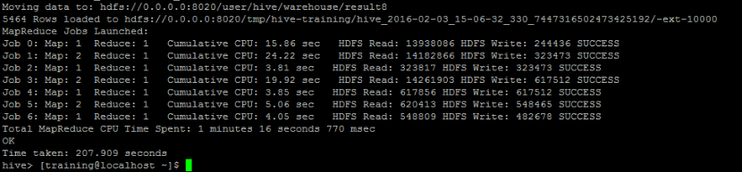

3.1 HIVE EXECUTION TIME WITH TWEAKED SETTINGS
- Cost based query optimization

By default this parameter is set to false, enable it by setting:

hive> set hive.cbo.enable=true;
hive> set hive.compute.query.using.stats=true;
hive> set hive.stats.fetch.column.stats=true;
hive> set hive.stats.fetch.partition.stats=true;

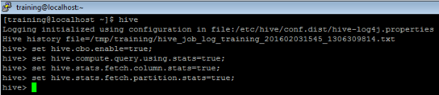

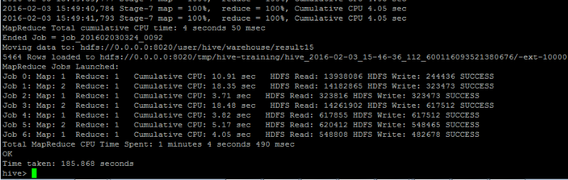

Running the query post these settings, it took total execution time of 185.868 seconds (Saved 22.041 seconds compared to default time).

- Enable or set COMBINER

By default this parameter is set to false, enable it by setting:

hive> set hive.exec.combiner=true;

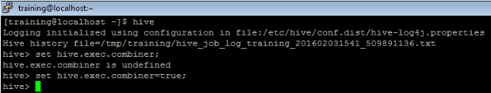

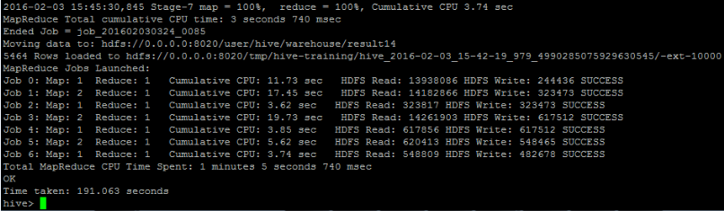

Running the query post these settings, it took total execution time of 191.063 seconds (Saved 16.846 seconds compared to default time).

- Run in local mode

By default this parameter is set to false, enable it by setting:

hive> set hive.exec.mode.local.auto=true;

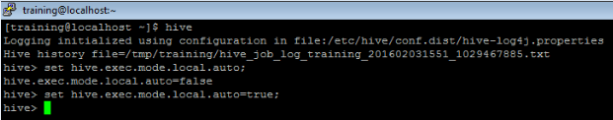

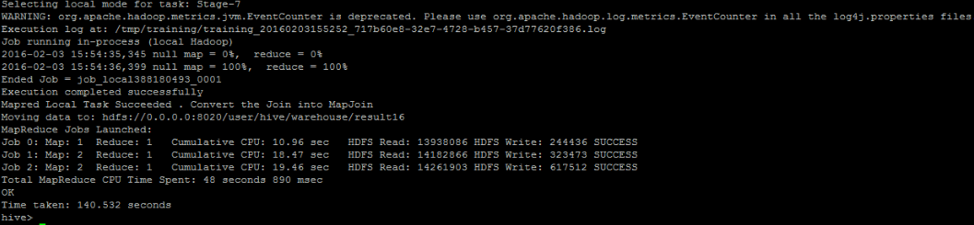

Running the query post these settings, it took total execution time of 140.532 seconds (Saved 67.377 seconds compared to default time).

- Map side join

By default this parameter is set to false, enable it by setting:

hive> set hive.exec.mode.local.auto=true;
hive> set hive.auto.convert.join=true;

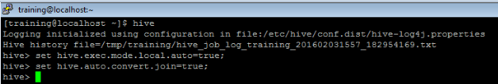

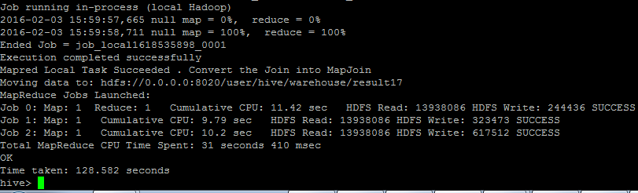

Running the query post these settings, it took total execution time of 128.582 seconds (Saved 79.327seconds compared to default time).

- Compressing Map output

By default this parameter is set to false, enable it by setting:

hive> set mapred.compress.map.Output;
hive> set mapred.map.output.compression.codec; (Default compression codec, can use any other like snappy etc..,)

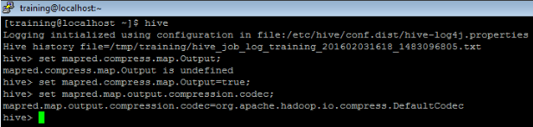

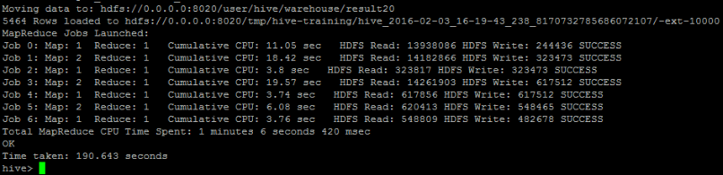

Running the query post these settings, it took total execution time of 190.643 seconds (Saved 17.266seconds compared to default time).

- Compressing final output

By default this parameter is set to false, enable it by setting:

hive> set mapred.output.compress=true;

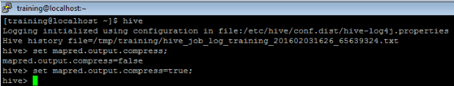

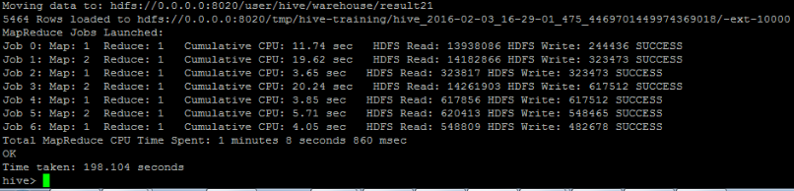

Running the query post these settings, it took total execution time of 198.104 seconds (Saved 9.805seconds compared to default time).

- Increasing local MapReduce memory

By default this parameter is set to zero in Pseudo distributed or local mode, change it by setting:

hive> set hive.mapred.local.mem=50;

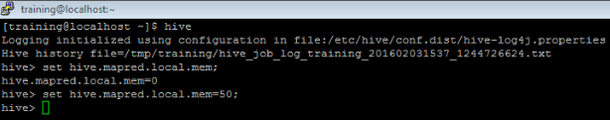

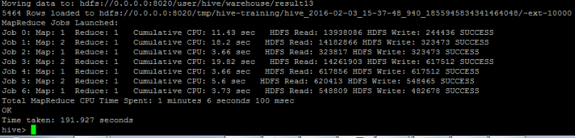
Running the query post these settings, it took total execution time of 191.927 seconds (Saved 15.982seconds compared to default time).

- Partitioning

To enable dynamic partitioning:

hive> set hive.exec.dynamic.partition= true;
hive> set hive.exec.dynamic.partition.mode=nonstrict;

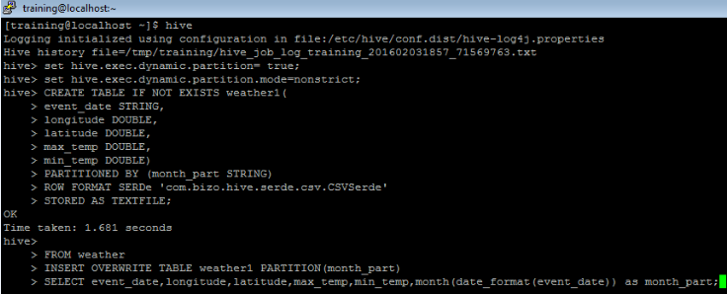

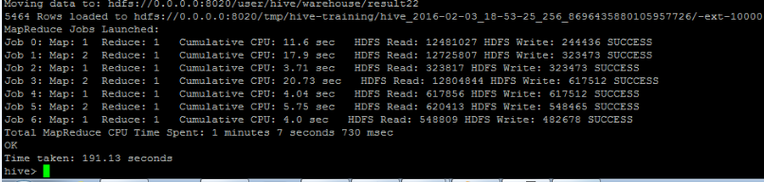

Running the query post these settings, it took total execution time of 191.13 seconds (Saved 16.779seconds compared to default time).

- Enable Vectorization

By default this parameter is set to false, enable it by setting:

hive> set hive.vectorized.execution.enabled = true;
hive> set hive.vectorized.execution.reduce.enabled = true;

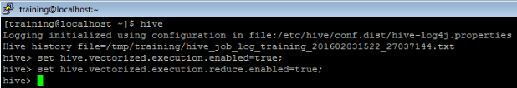

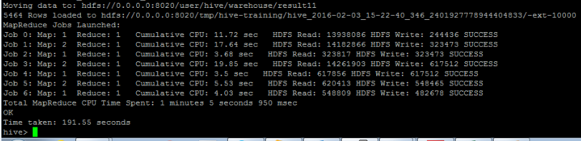

Running the query post these settings, it took total execution time of 191.55 seconds (Saved 16.359seconds compared to default time).

- Parallel execution
By default this parameter is set to false, enable it by setting:
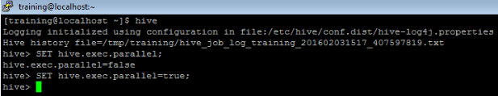
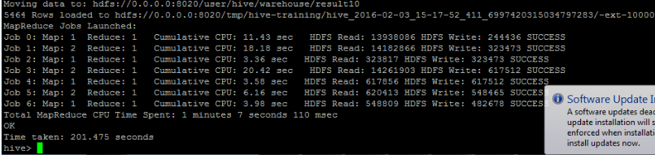
Running the query post these settings, it took total execution time of 201.475 seconds (Saved 6.434 seconds compared to default time).

3.2 APPLYING ALL ABOVE MENTIONED TWEAKED SETTINGS
Applying above all settings, it took total execution time of 116.333 seconds (Saved 91.576seconds compared to default time).
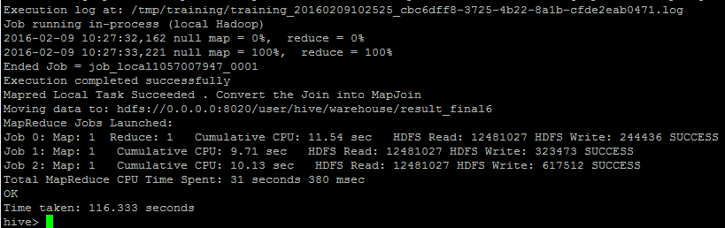

4 IMPALA EXECUTION ON NATIVE HIVE TABLES
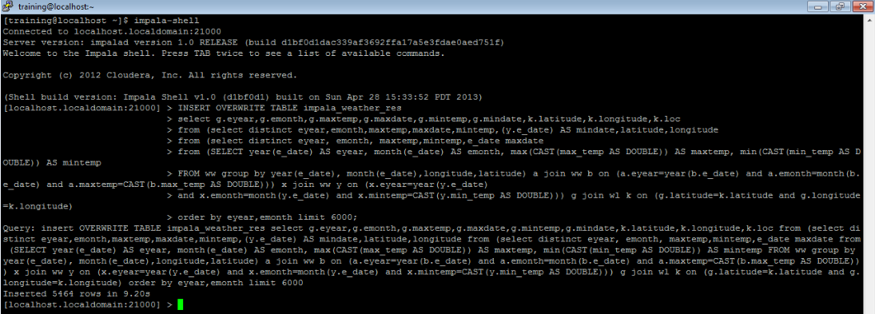

The query took 9.20 seconds for executing on native HIVE tables from impala shell.

4.1 IMPALA EXECUTION ON NATIVE IMPALA TABLES
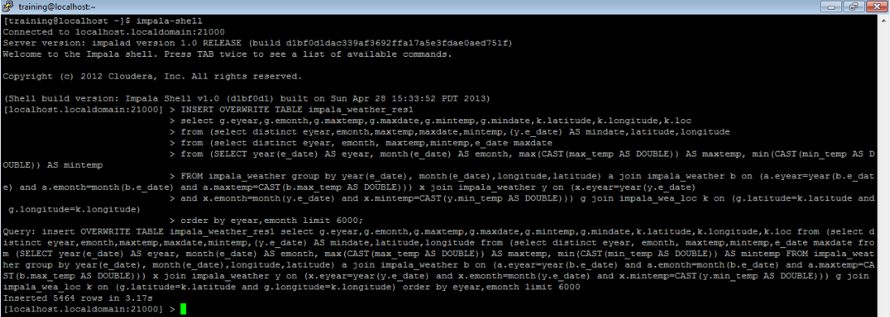
The query took 3.17 seconds for executing on native IMPALA tables from impala shell.
4.2 SAMPLE RESULT POST IMPALA EXECUTION

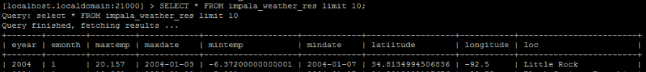

The above image showing sample result of the query.
4.3 IMPALA EXECUTION TIME WITH TWEAKED SETTINGS

- Storing tables as Parquet file

By Default once we create table it will be saved as Text file, Impala gives good performance on Parquet compared to other formats. We can achieve this by using STORES AS parquetfile while creating table in impala.

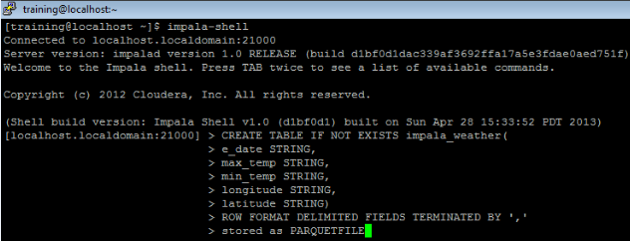

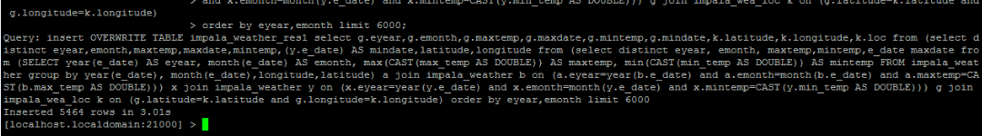

The query took 3.01 seconds for executing on IMPALA tables stores as parquetfile.
- Using Partition by

Creating table in Impala by partition by column.

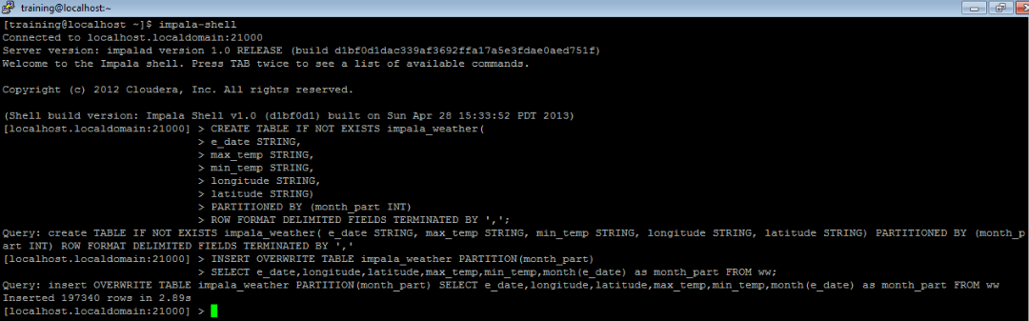
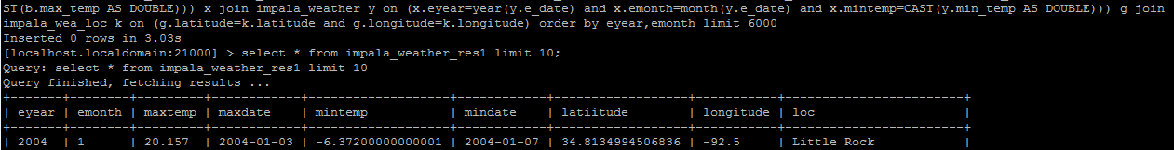
The query took 3.03 seconds for executing on IMPALA partition by tables.

- Scanner Threads

By default no of scanner threads is set to zero, we can increase it by setting:

>set NUM_SCANNER_THREADS=1;

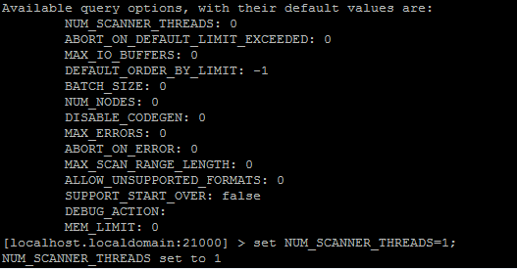

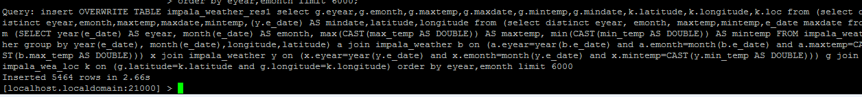

The query took 2.66 seconds for executing post these settings.

5 SUMMARY

5.1 HIVE PERFORMANCE RESULTS

PROPERTY | DEFAULT EXECUTION TIME  (In Seconds) | POST SETTING EXECUTION TIME  (In Seconds) | Time saved  (In Seconds)
Default execution | 207.909 | N/A | N/A
set hive.cbo.enable=true;  set hive.compute.query.using.stats=true;  set hive.stats.fetch.column.stats=true;  set hive.stats.fetch.partition.stats=true; | 207.909 | 185.868 | 22.041
set hive.exec.combiner=true; | 207.909 | 191.063 | 16.846
set hive.exec.mode.local.auto=true; | 207.909 | 140.532 | 67.377
set hive.exec.mode.local.auto=true;  set hive.auto.convert.join=true; | 207.909 | 128.582 | 79.327
set mapred.compress.map.Output;  set mapred.map.output.compression.codec; | 207.909 | 190.643 | 17.266
set mapred.output.compress=true; | 207.909 | 198.104 | 9.805
set hive.mapred.local.mem=50; | 207.909 | 191.927 | 15.982
SET hive.exec.parallel=true; | 207.909 | 201.475 | 6.434
set hive.exec.dynamic.partition= true;  set hive.exec.dynamic.partition.mode=nonstrict; | 207.909 | 191.13 | 16.779
set hive.vectorized.execution.enabled=true;  set hive.vectorized.execution.reduce.enabled=true; | 207.909 | 191.55 | 16.359
Applying above all settings | 207.909 | 116.333 | 91.576

5.2 IMPALA PERFORMANCE RESULTS
PROPERTY | DEFAULT EXECUTION TIME  (In SECONDS) | POST SETTING EXECUTION TIME  (In SECONDS) | TIME SAVED  (In SECONDS)
Default execution on native HIVE tables | 9.20 | NA | NA
Default execution on native IMPALA tables | 3.17 | NA | NA
Performing query on Partitioned table | 3.17 | 3.03 | 0.14
Performing query on table stored as Parquetfile | 3.17 | 3.01 | 0.16
Set NUM_SCANNER_THREADS=1; | 3.17 | 2.66 | 0.51

CONTACT DETAILS
Please contact for further info on this document
Enterprise id : Karunakar Naidu
Email id : Karunakar.naidu@accenture.com
Contact no : +91 9986639493

